NAME:

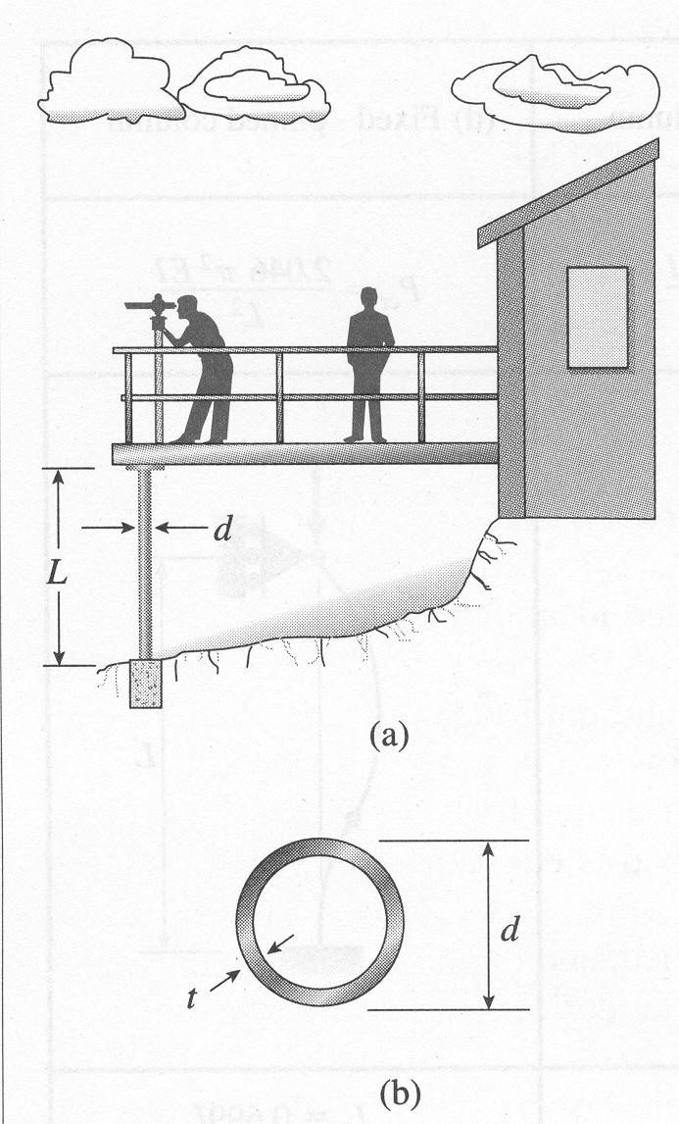
Problem 1: A viewing platform in a wild-animal park is supported by a row of aluminum pipe columns having length L=3.25m and outer diameter d=100mm. The bases of the columns are set in concrete footings and the tops of the columns are supported laterally (pinned) by the platform. The columns are being designed to support compressive loads P=100kN.

1a. Determine the minimum required thickness t of the columns if a factor of safety n=3 is required with respect to Euler buckling (P_{cr}=3P).

1b. Calculate the compressive stress in the column under maximum loading. Is the beam in the Euler domain of buckling? Explain your answer.
PROBLEM 2: Using singularity functions, write expressions for the shear, bending moment, curvature, and deflection of the beam shown. Be sure to calculate all integration constants.
1.2kN
1.5kN/m
1.44kNm
0.6m
1.2m
0.8m
1.0m

PROBLEM 3: Sketch the shear, moment, curvature, and deflection diagrams.
a
a
a
Fa
F

BONUS (10pts): Using the moment area method, determine the deflection of the free end, the curvature of the free end, the curvature of the pinned end.

